A
SYNOPSIS ON
IOT BASED EARLY FLOOD DETECTION AND AVOIDANCE

A Project Submitted in Partial Fulfillment of the Requirements for the Degree of Bachelor of
Technology
in
ELECTRONICS AND COMMUNICATION ENGINEERING

SUBMITTED BY

2002220310005 AYUSH RAJ
2002220310020 SUMAN KUMAR
2002220310021 UMESH KUMAR

UNDER THE SUPERVISION OF

Mr. Shahid Khan – Assistant Professor


SUBMITTED TO

DEPARTMENT OF ELECTRONICS AND COMMUNICATION ENGINEERING
I.T.S ENGINEERING COLLEGE, GREATER NOIDA
(Affiliated to Dr. APJ Abdul Kalam Technical University, Lucknow)

ABSTRACT

Project Title: IOT BASED EARLY FLOOD DETECTION AND AVOIDANCE.

Problem Statement:

Rising waters engulfing roads, homes, and entire communities. The familiar rhythm of life replaced by the relentless surge of floods, their fury carving a path of devastation across our land. This isn't a scene from a disaster movie; it's the unfolding reality of our planet, where climate change is fueling more frequent and intense floods, threatening lives, livelihoods, and the very fabric of our society.

These aren't just temporary inconveniences. Floods wreak havoc on infrastructure, disrupt economies, and leave behind a trail of displacement and trauma. Our homes, our businesses, our very sense of security – all are at stake. Current flood mitigation strategies struggle to keep pace, leaving us scrambling to react after the waters have already risen.

This is not a problem we can ignore or simply adapt to. We need to act proactively, embracing innovative solutions that can predict, prevent, and prepare for the floods of tomorrow. This requires a collective effort, a commitment from individuals, communities, and governments to invest in technology, infrastructure, and education that safeguards our future.

Literature Survey:
As floods become an increasingly menacing reality fuelled by climate change, innovative tools like IoT-based flood detection and early warning systems (FDWS) emerge as promising guardians of vulnerable communities. These networks weave a web of intelligent sensors across rivers, dams, and critical areas, tirelessly monitoring water levels, rainfall, and even soil moisture. Powerful algorithms then analyse this real-time data, predicting floods with increasing accuracy and precious lead time. Timely warnings are unleashed through multi-channel sirens, mobile apps, and even SMS, ensuring everyone in harm's way is informed and prepared. But this proactive approach doesn't stop at alerts; communities are empowered through educational programs and informed infrastructure development, building long-term resilience against the rising tide. While challenges remain, like optimizing sensor networks and combating data security threats, continuous advancements in AI and personalized warning systems promise even more effective flood mitigation strategies for a safer future. In essence, IoT-based FDWS offer not just flood warnings, but a lifeline of hope and empowerment for communities living on the edge of uncertainty.
This paragraph condenses the previous literature survey into a single, impactful paragraph, highlighting the key points and benefits of IoT-based flood detection systems. Remember, you can further tailor this paragraph to your specific presentation or audience by emphasizing certain aspects or incorporating unique details relevant to your project.
Rationale for topic selection:
There are several compelling reasons why choosing "flood detection and mitigation using IoT technology" as your presentation topic is impactful and relevant:
Urgency and Relevance:
- Global Challenge: Floods are a growing global threat, impacting millions of people every year. Climate change is exacerbating existing flood risks, making it a timely and crucial issue to address.
- High Impact: Floods cause widespread destruction, disrupting lives, livelihoods, and economies. Highlighting this significant impact resonates with audiences and emphasizes the need for solutions.
- Technological Intervention: IoT offers innovative solutions for flood detection and mitigation, making it a promising and exciting angle to explore.
Innovation and Interest:
- Cutting-Edge Technology: IoT is a rapidly evolving field with exciting potential for solving various challenges. Presenting its application in flood management showcases its capabilities.
- Unique Approach: Combining IoT with flood detection offers a fresh perspective on a familiar problem. This creative approach can captivate the audience and keep them engaged.
- Practical Applications: Highlighting real-world case studies and specific IoT-based solutions demonstrates the practicality and effectiveness of this technology, making it relatable and engaging.
Call to Action:
- Proactive Mitigation: The presentation can promote a shift from reactive disaster response to proactive flood management, fostering a sense of empowerment and responsibility in the audience.
- Community Engagement: Discussing community-based initiatives and individual-level actions shows how everyone can contribute to building flood-resilient communities.
- Policy Advocacy: Raising awareness about the limitations of current approaches can pave the way for advocating for increased investment in IoT-based flood management systems and infrastructure.

Objective of Project:

To weave a safety net of technology across vulnerable landscapes. This integrated IoT-based flood detection system will combine real-time data, predictive analytics, and automated alerts to outwit the rising waters. Its aim? To provide communities with precious lead time through early warnings, streamline response efforts by pinpointing critical areas, and instil lasting resilience through informed infrastructure and preparedness programs. Ultimately, this project aspires to empower communities and safeguard lives, transforming them from flood victims to proactive sentinels of their own safety.
What will this project do?
- Automated Siren Song: Triggers instant alerts via SMS, apps, and sirens, ensuring everyone in harm's way is warned and prepared.
- Smarter Resource Guardian: Pinpoints flood-prone areas, guiding rescue efforts and optimizing resource allocation to maximize impact.
- Future-Proofing Communities: Informs infrastructure development and flood-resilient planning, building communities strong enough to withstand the waters.
- Empowering Citizens: Educates and equips individuals with knowledge and skills to stay safe and adapt to a changing climate.
- Early Warning Prophet: Senses water levels, rainfall, and soil moisture, predicting floods with high accuracy, giving communities precious lead time.
Key Features:
- Sensor Network: A web of intelligent sensors across rivers, dams, and critical areas, monitoring water levels, rainfall, and ground movement in real-time.
- Predictive Brain: Machine learning algorithms analyze data from sensors, historical records, and weather forecasts, predicting floods with pinpoint accuracy.
- Instantaneous Alerts: Multi-channel warning system triggers SMS, app notifications, and sirens, ensuring everyone at risk receives timely alerts.
- Dynamic Response: Optimizes resource allocation by directing response efforts to the areas most impacted by the predicted flood.
- Community Resilience: Encourages long-term flood preparedness through educational programs, risk mapping, and infrastructure development based on real-time data.
Benefits:
- Lives Saved: Early warnings and accurate predictions enable timely evacuations, minimizing casualties and safeguarding communities.
- Reduced Devastation: Proactive flood mitigation measures like automated dam control and intelligent water flow management lessen property damage and infrastructure disruption.
- Informed Planning: Real-time data and flood forecasting guide future infrastructure development and resource allocation, creating resilient communities better equipped for future flood events.
- Empowered Citizens: Educational programs and accessible flood information make individuals aware of risks, prepared for emergencies, and proactive in their own safety.
- Cost Efficiency: Precise response efforts based on real-time data optimize resource allocation, saving time, money, and valuable resources.
- Global Impact: This scalable solution can be adapted to diverse landscapes and populations, offering a blueprint for flood mitigation on a global scale.
By harnessing the power of IoT, this project transforms the narrative of floods from fear and devastation to one of resilience, preparation, and empowered communities standing strong against the rising tide. Remember, you can tailor these benefits to your specific project and target audience, highlighting the most relevant and impactful aspects of your solution.

Block Diagram:
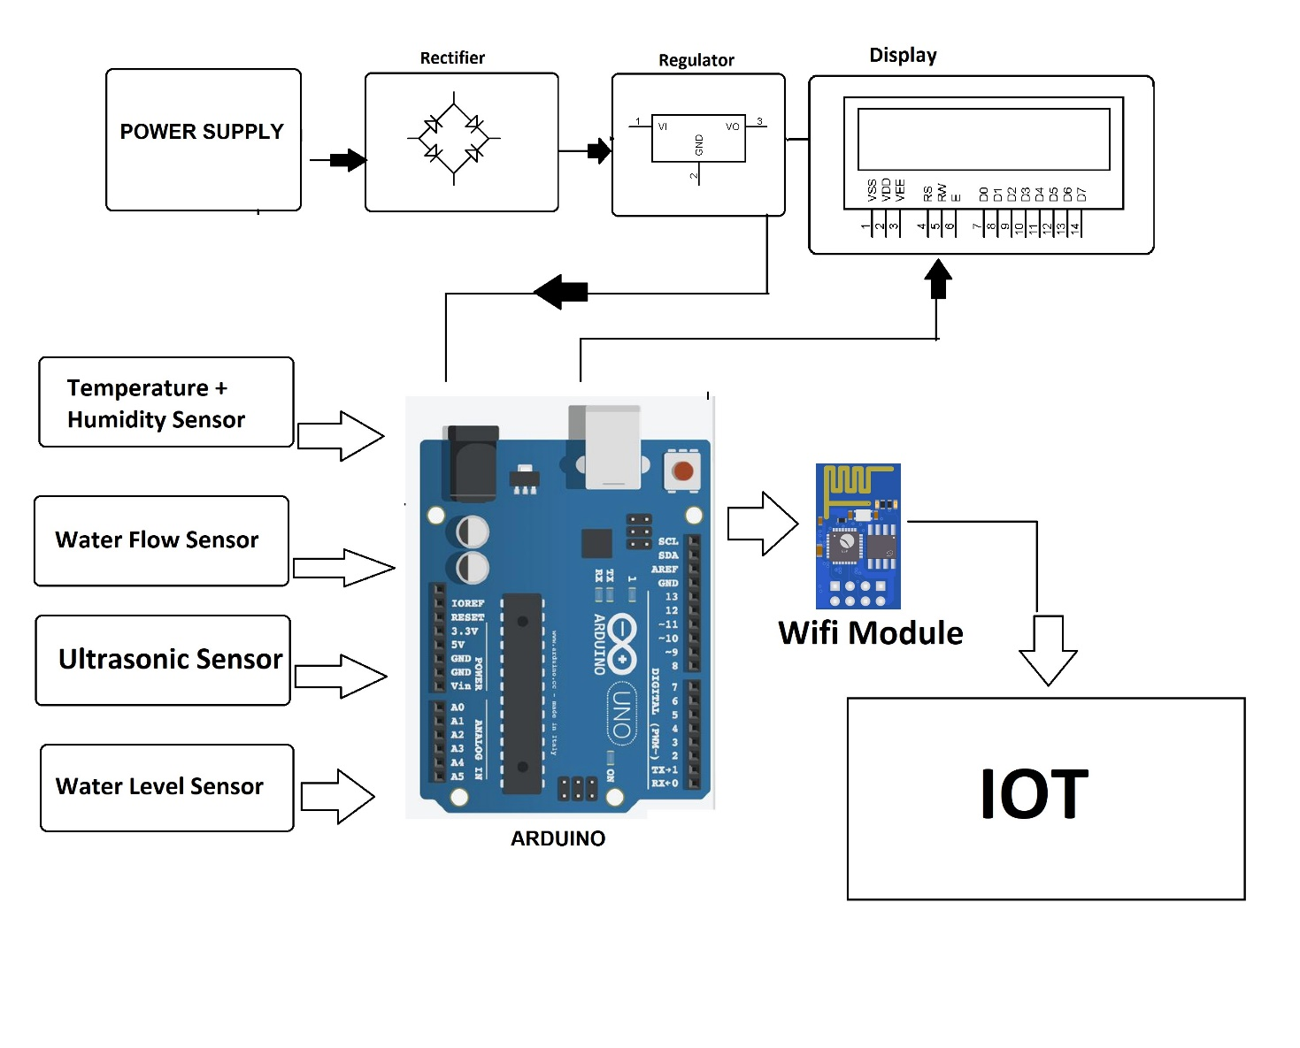
Scope of the Project:
The future of this Iot based flood detection and early avoidance holds exciting possibilities in several areas:
- Geographic Focus: This defines the specific region or areas where the project will be implemented.
- Technology Stack: This outlines the specific sensors, hardware, software, and communication protocols used in the IoT system.
- Data Analysis and Prediction: This describes the algorithms, models, and tools used to analyze sensor data and predict flood events.
- Alerting and Warning System: This details the channels and mechanisms used to disseminate warnings to communities at risk.
- Resource Optimization: This explains how the project will leverage real-time data to optimize resource allocation during flood events.
- Community Engagement: This defines the project's approach to educating and empowering local communities for preparedness and resilience.
- Project Deliverables: This lists the tangible outcomes of the project, such as deployed sensor networks, data analysis platforms, and educational materials.
Methodology:
The methodology for the proposed Iot based early flood detection and avoidance can be described through several key points:
1. Needs Assessment and Site Selection:
- Conduct thorough research to identify flood-prone areas and understand community needs.
- Engage with stakeholders (local authorities, community members, potential partners) to gather insights and build support.
- Select suitable sites for sensor placement based on hydrological factors, accessibility, and communication infrastructure.
2. Hardware and Software Design:
- Choose appropriate sensors (water level, rainfall, soil moisture, etc.) based on project requirements and environmental conditions.
- Select a microcontroller or gateway device to collect and transmit sensor data.
- Develop or choose a software platform for data collection, storage, analysis, and visualization.
- Design a user-friendly interface for viewing real-time data and warnings.
3. Network Deployment and Integration:
- Install sensors and communication infrastructure (cellular, LoRaWAN, etc.) in the selected areas.
- Establish reliable communication links between sensors and the central data platform.
- Integrate the IoT system with existing flood management systems or disaster response platforms, if applicable.
4. Data Collection and Analysis:
- Collect real-time sensor data continuously and store it securely.
- Develop and implement algorithms for flood prediction, using techniques such as machine learning, statistical analysis, and hydrological modeling.
- Validate model accuracy using historical data and ground-truth observations.
5. Warning System Implementation:
- Establish a multi-channel warning system, including SMS, mobile apps, sirens, and social media integration.
- Define clear warning thresholds and protocols for dissemination.
- Conduct regular testing and drills to ensure system reliability and community preparedness.
6. Community Engagement and Education:
- Raise awareness about the project and its benefits within the community.
- Conduct training sessions on system usage and flood preparedness.
- Encourage feedback and participation from community members to refine the system.
7. Evaluation and Maintenance:
- Regularly monitor system performance and assess its impact on flood mitigation.
- Conduct periodic maintenance and calibration of sensors and communication equipment.
- Update algorithms and software based on new data and insights.
- Adapt the system to evolving needs and challenges.
Software And Technology Use:
The specific software and technology used in your IoT-based flood detection project will depend on several factors, including:
Project Scale and Scope:
Large-scale projects: May utilize cloud-based platforms like Azure IoT Hub or AWS IoT Core for central data management and analytics.
Smaller deployments: May favor on-premise solutions with microcontrollers like Raspberry Pi or Arduino coupled with local data storage and analysis.
Sensor Data Acquisition and Communication:
Sensor types: Sensors for water level, rainfall, soil moisture, and environmental conditions will utilize specific protocols like I2C, SPI, or analog inputs.
Communication protocols: Low-power, wide-area networks like LoRaWAN or Sigfox are ideal for remote locations. Cellular or Wi-Fi can be used for areas with stronger infrastructure.
Data Analysis and Prediction:
Machine learning algorithms: Time series analysis, regression models, and anomaly detection algorithms can be used to predict flood events based on sensor data and historical records.
Hydrological modeling software: Tools like HEC-RAS and SWMM can be integrated for advanced flood simulation and forecasting.
Warning System and Visualization:
Mobile apps: Flutter or React Native offer cross-platform app development for real-time data access and alerts.
SMS gateways: Integration with SMS services ensures notification reach even in areas with limited internet access.
Visualization tools: Dashboards and web interfaces can display real-time data, warnings, and flood simulations for stakeholders and communities.
Here are some specific examples of software and technology you could consider:
Sensors: LiDAR sensors for flood mapping, ultrasonic sensors for water level measurement, soil moisture sensors, weather stations.
Microcontrollers: Arduino Uno, Raspberry Pi, ESP32 for data acquisition and preprocessing.
Gateways: LoRa WAN gateways for long-range communication, cellular modems for wider coverage.
Data Platforms: Azure IoT Hub, AWS IoT Core, ThingSpeak, Ubidots for data storage, management, and analysis.
Machine Learning Tools: TensorFlow, scikit-learn, Python libraries for flood prediction algorithms.
Hydrological Modeling Software: HEC-RAS, SWMM for advanced flood simulation.
Mobile App Development: Flutter, React Native for cross-platform apps.
SMS Gateways: Twilio, Plivo for reliable SMS notifications.
Visualization Tools: Plotly, D3.js, Grafana for interactive dashboards and visualizations.

Contributors:
- AYUSH RAJ
- SUMAN KUMAR
- UMESH KUMAR

